**Day 7 Lab Assignments**

**Please do these assignments:**

1. Create a simple photo gallery like the following, and use opacity property to make each image fades out gradually (its opacity decreases to 0.3) when mouse is over it, and fades in gradually (its opacity increases to 1 gradually) when mouse is a way.



1. Make an array of colors and set of spans and a button with the text change Color and Background colors and when click in this button change the color and the background color randomly
2. Make a password input and a button with the text switch beside it when click in the button convert the password to be readable (change type for it)

s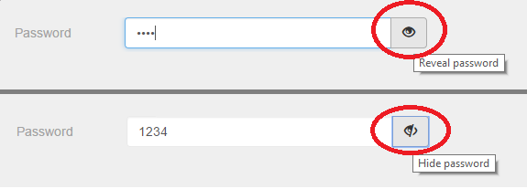

1. Make a bank of questions say 10 question and two buttons next and previous when click on the next navigate to the next question and when click on the previous one go to the previous question.
2. 3-Make an array that contains collection of colors and then in page load make a color of three paragraphs randomly from the array.
3. 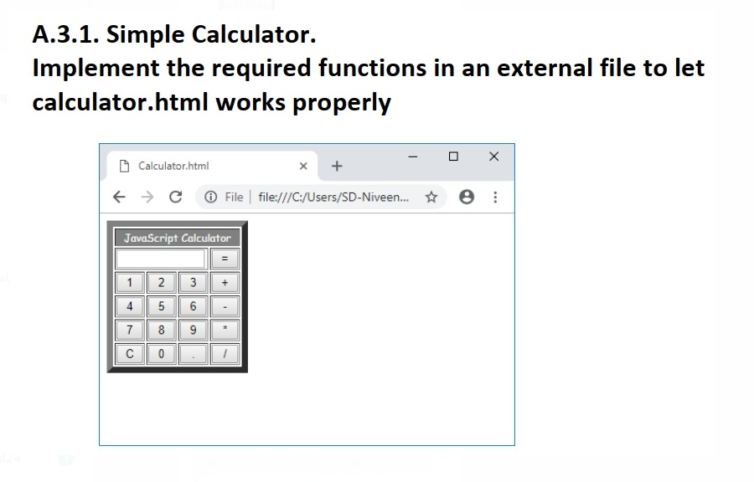

**<Script>document.write(“Thank YOU”) </Script>**